Gowtham Subramanian  
Michael Gildein  
Web Technologies  
MSIS_517L  
April 18, 2017

Assignment 8

**Q1. Google’s Page Speed Insight and Screenshots of webpage load times**

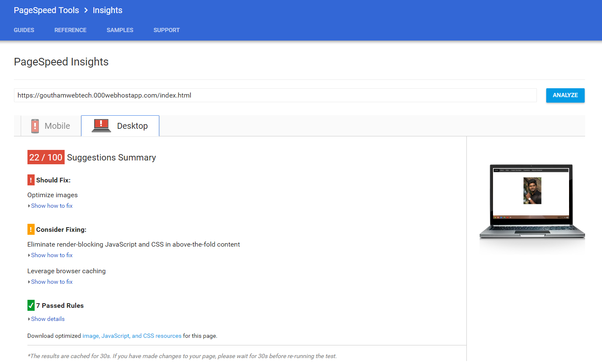

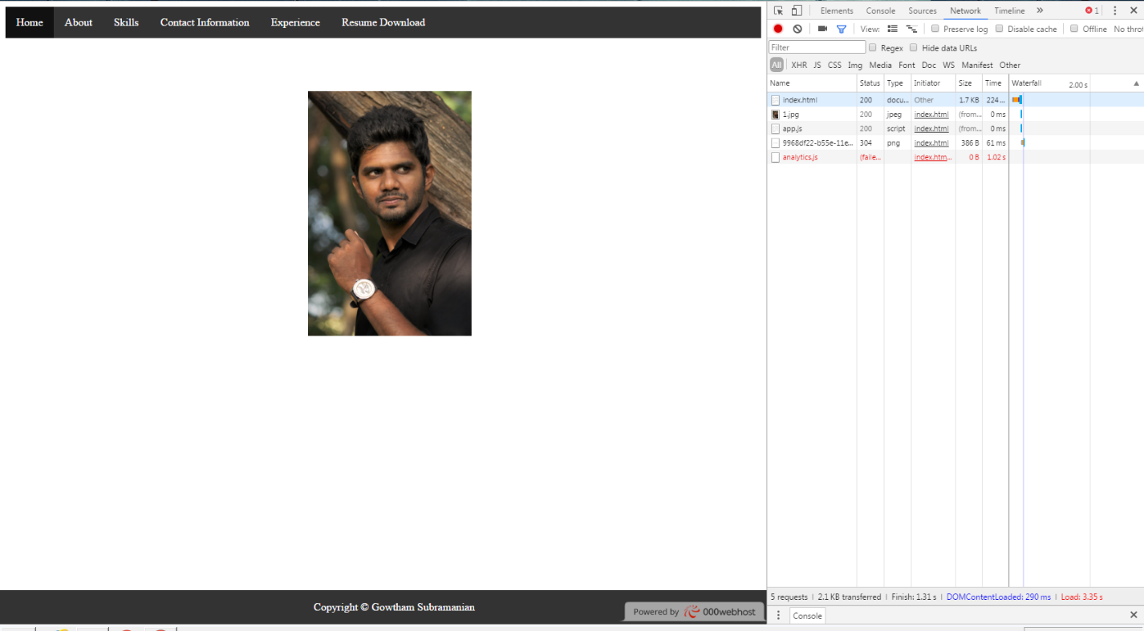

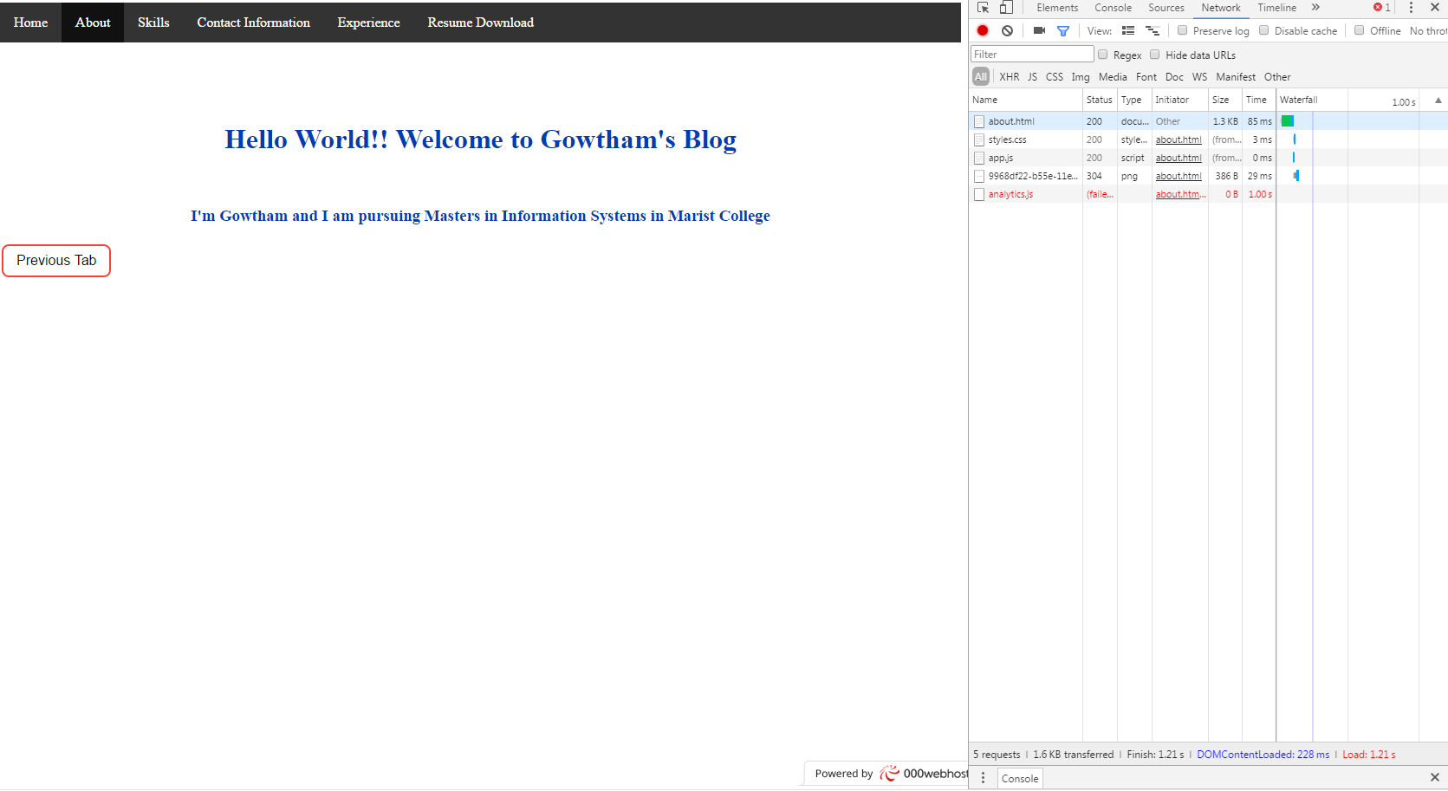

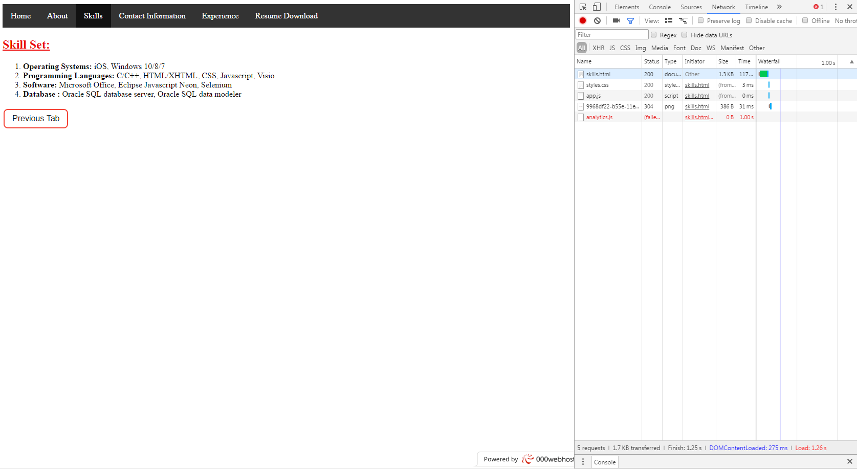

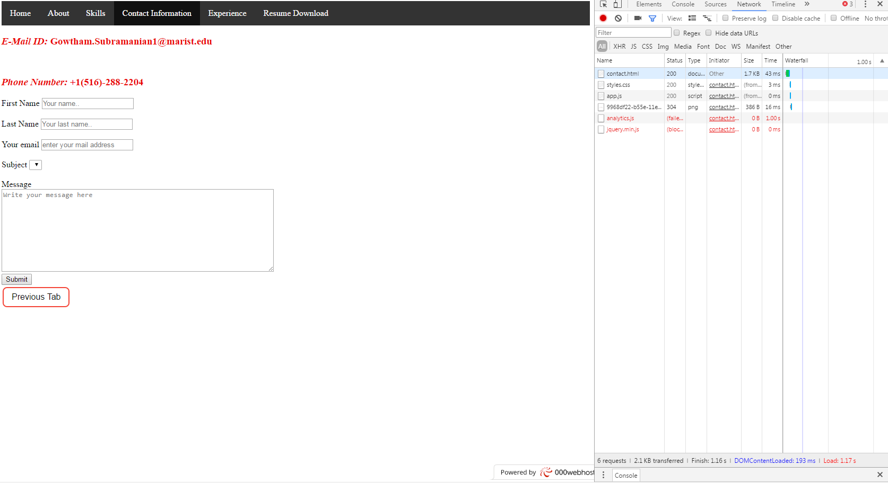

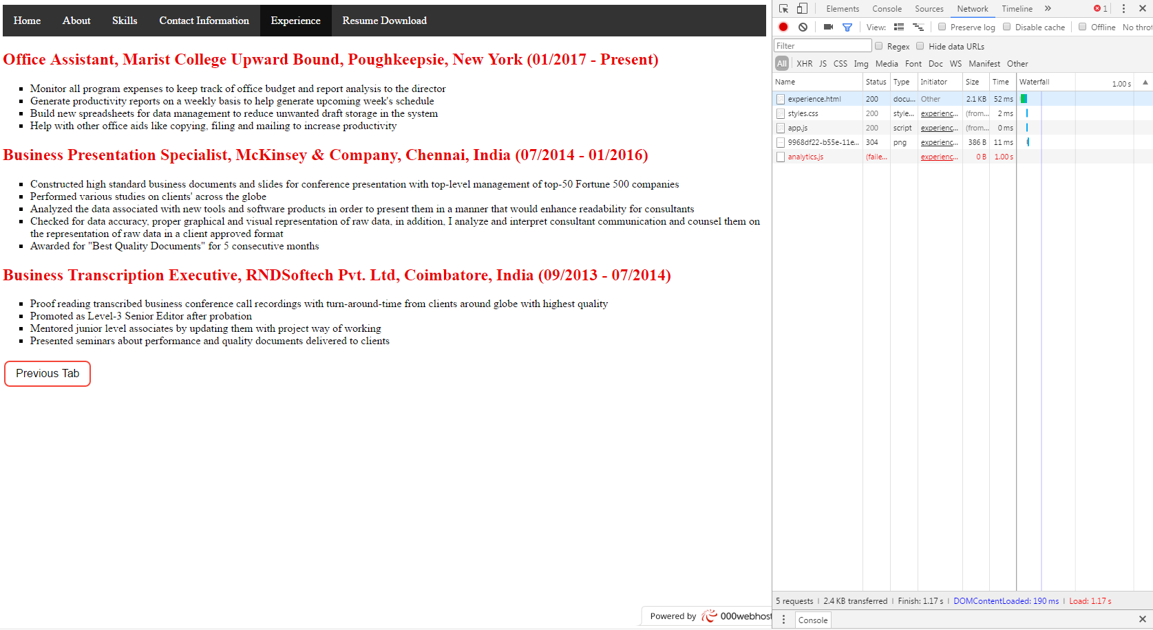

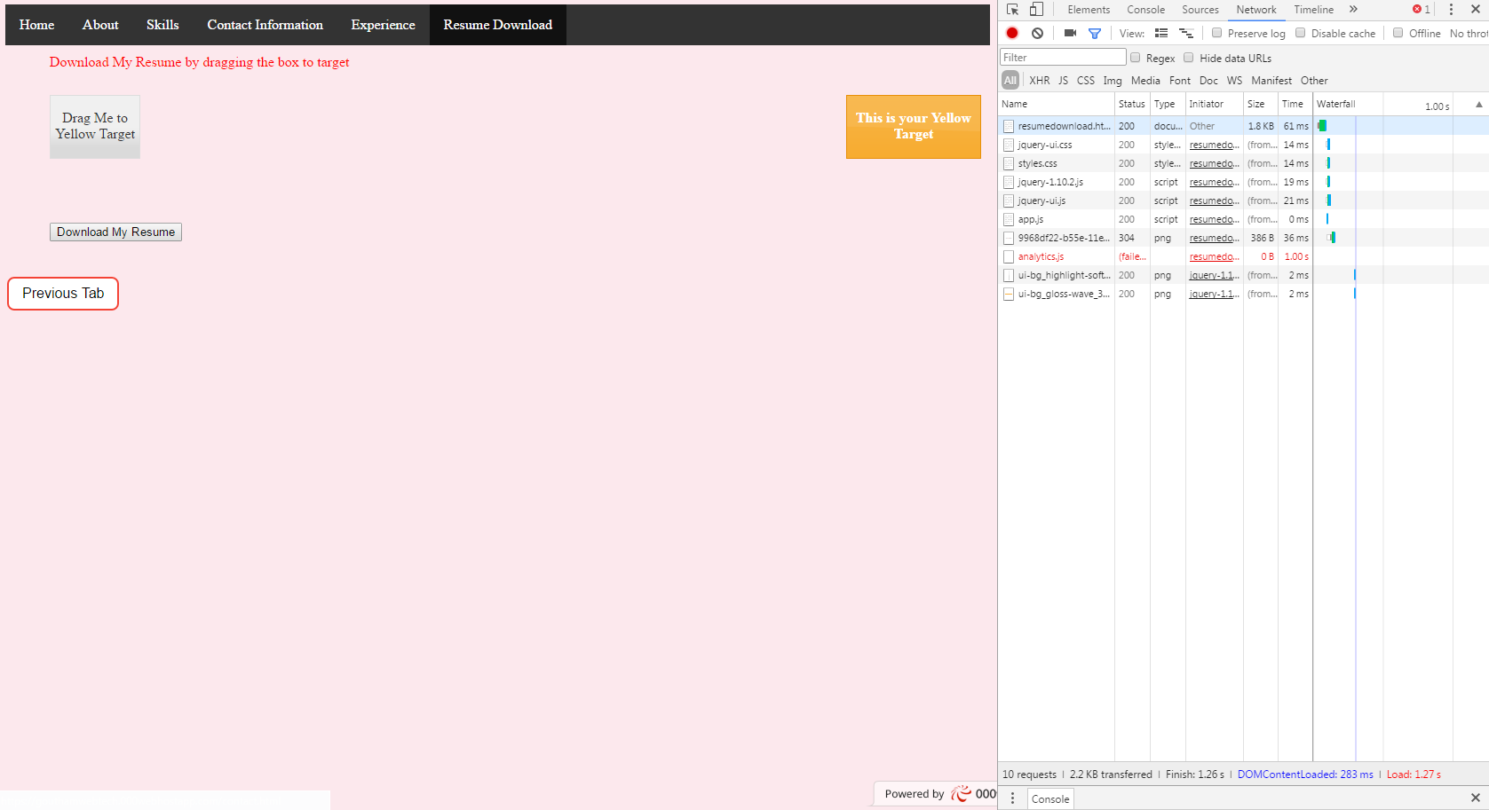

**Q2. Enhanced your website’s performance**

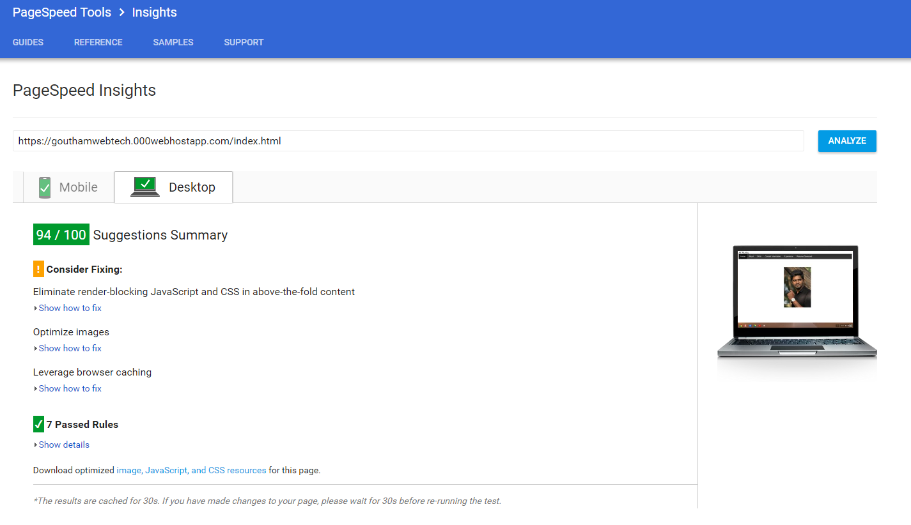

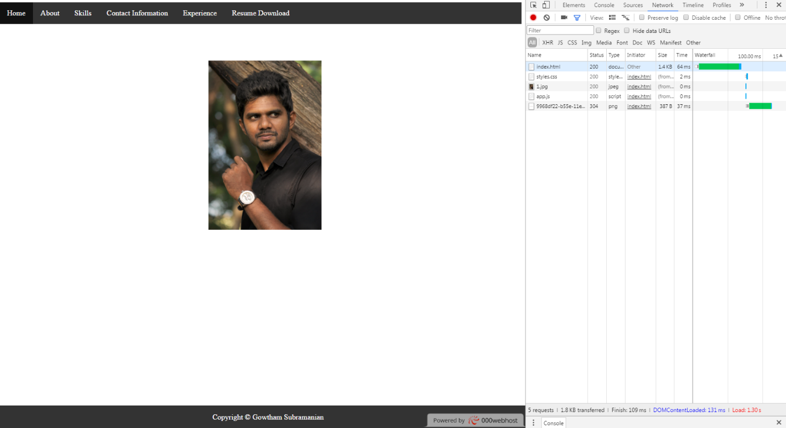

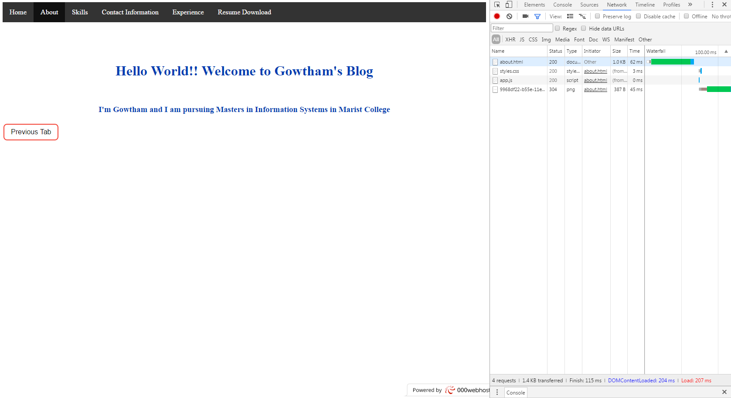

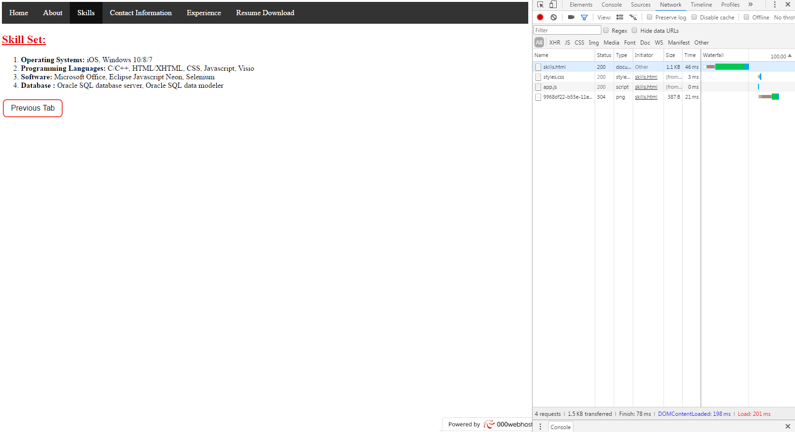

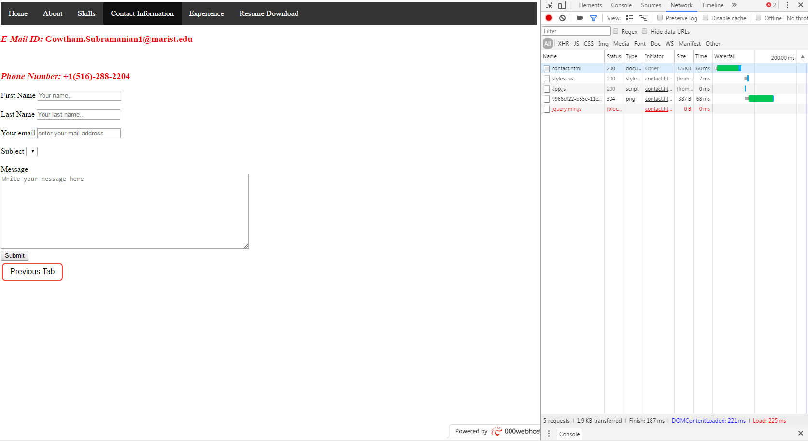

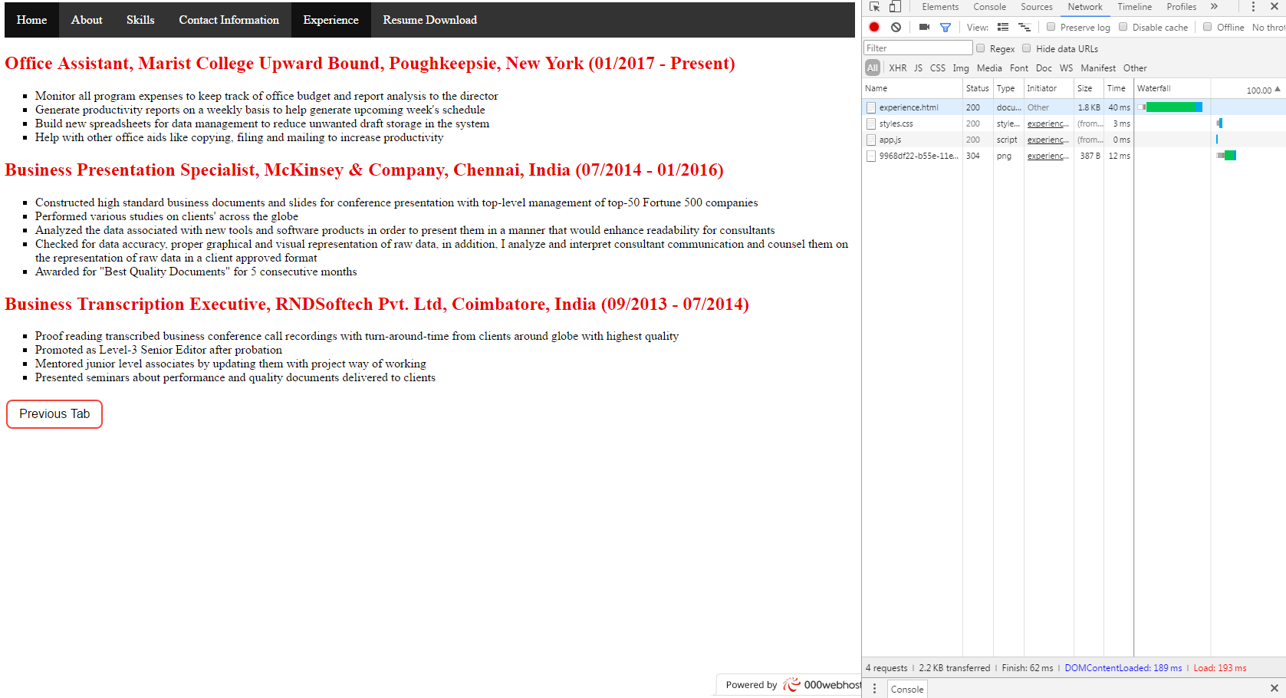

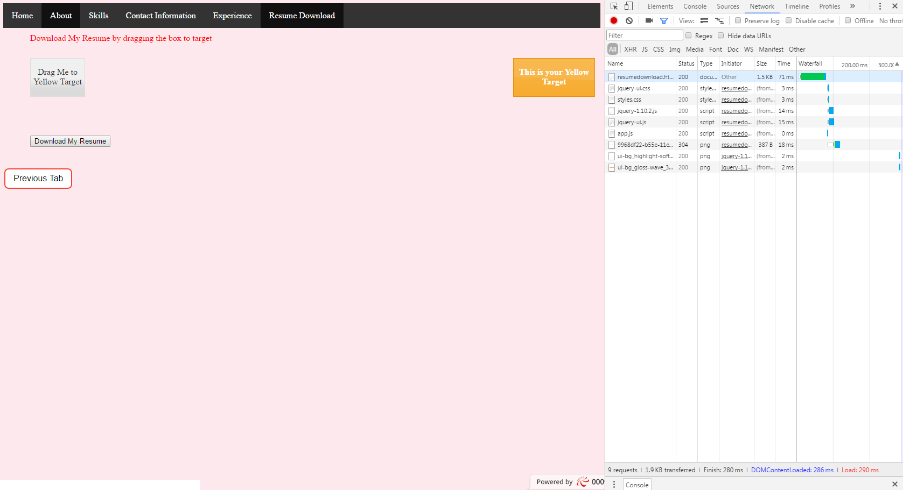

**Q3. Create another version of your site pages by minifying your code**

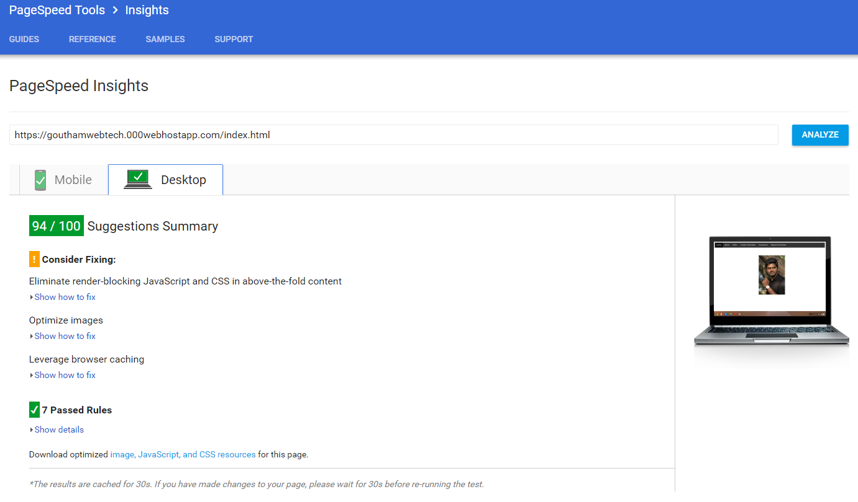

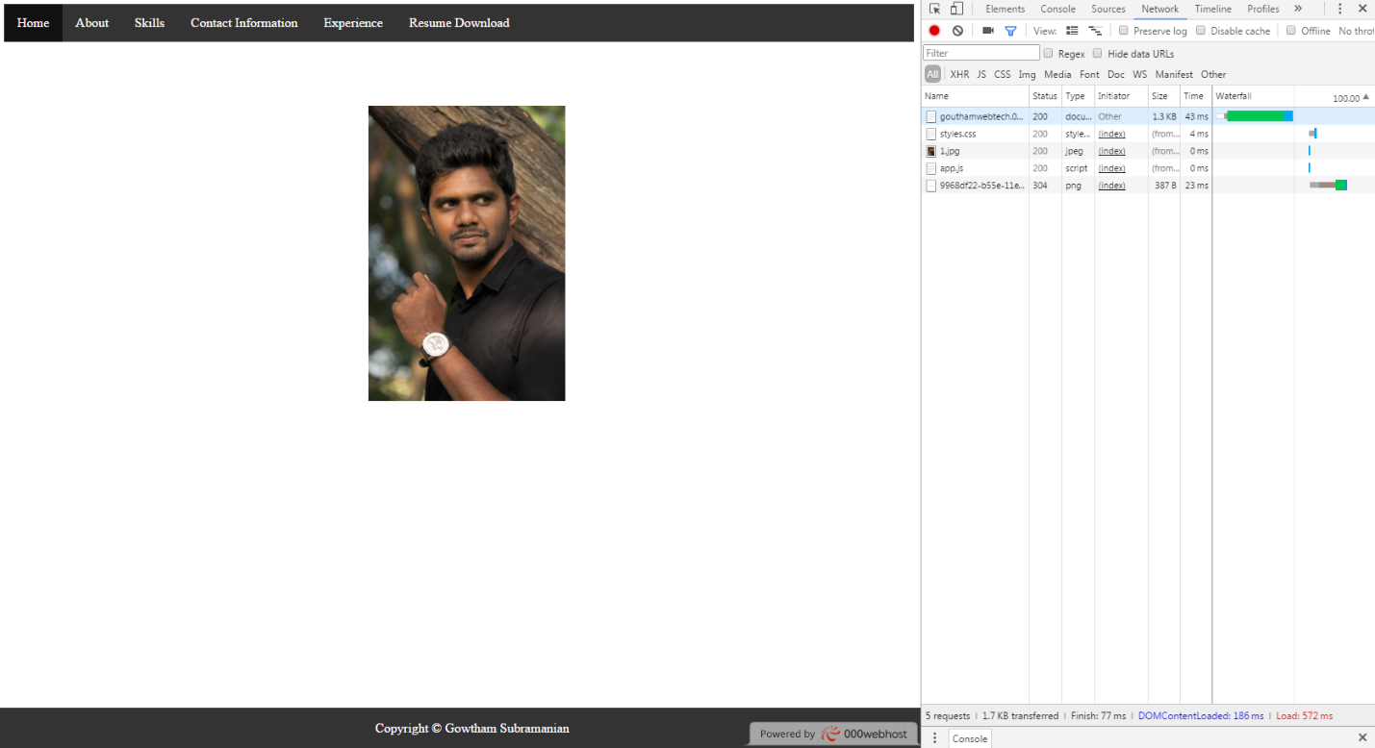

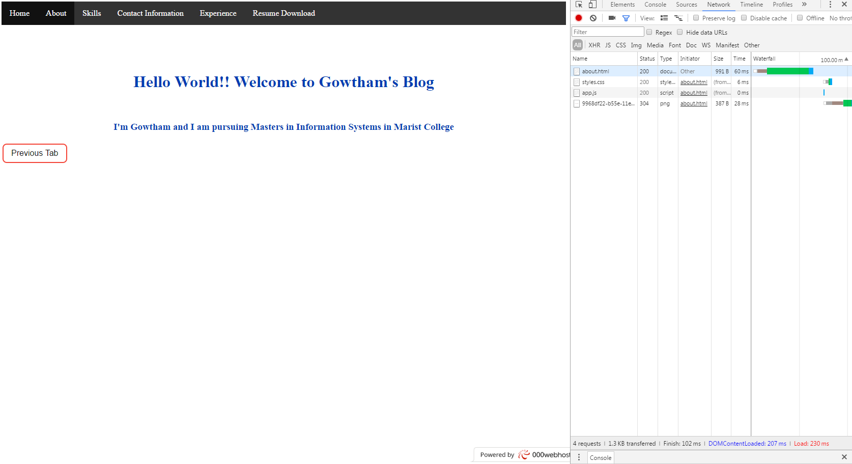

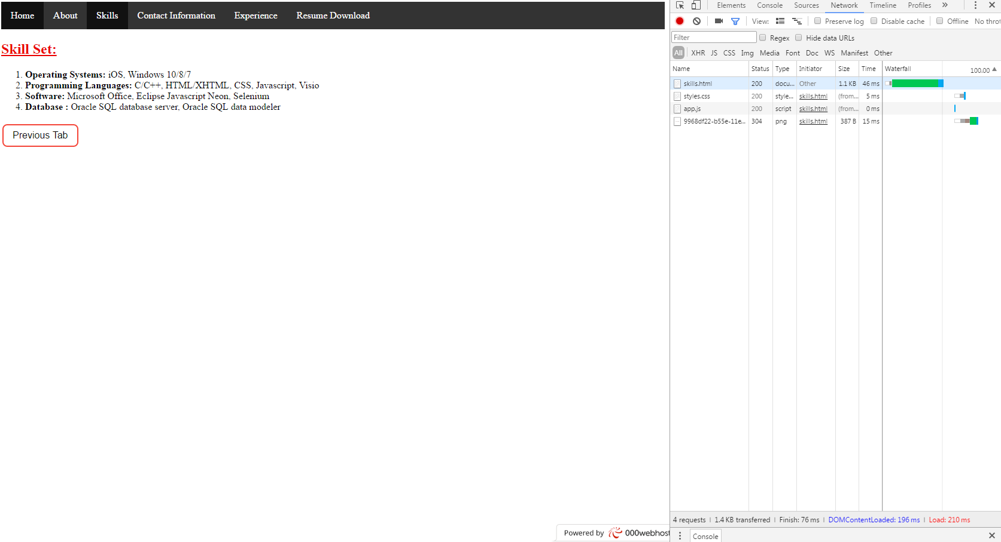

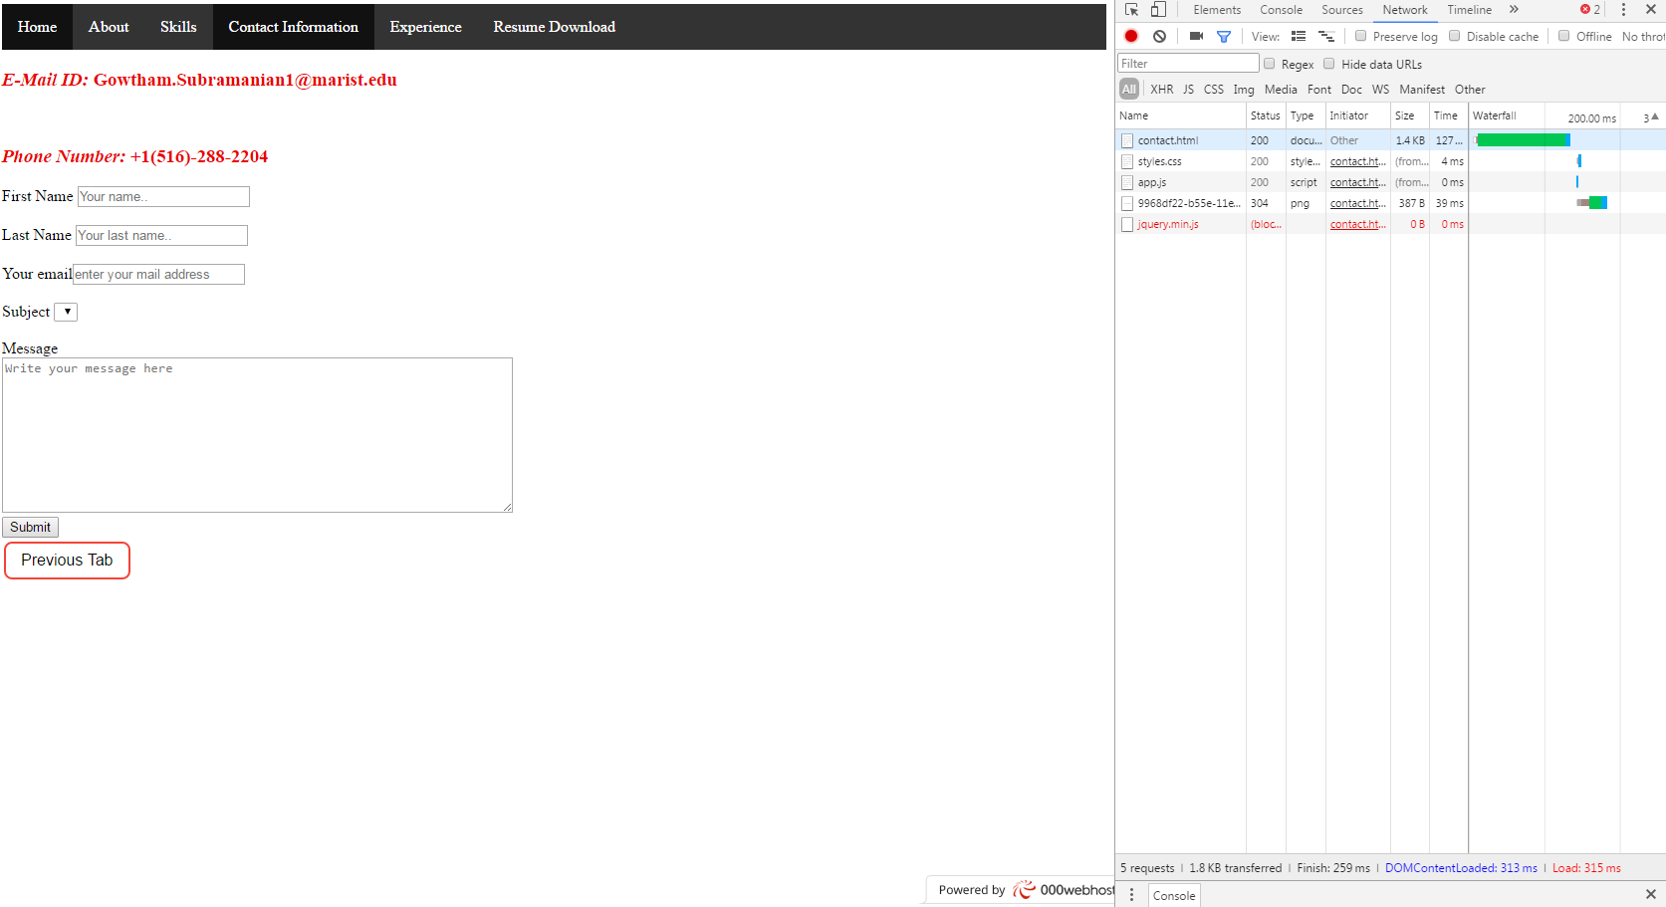

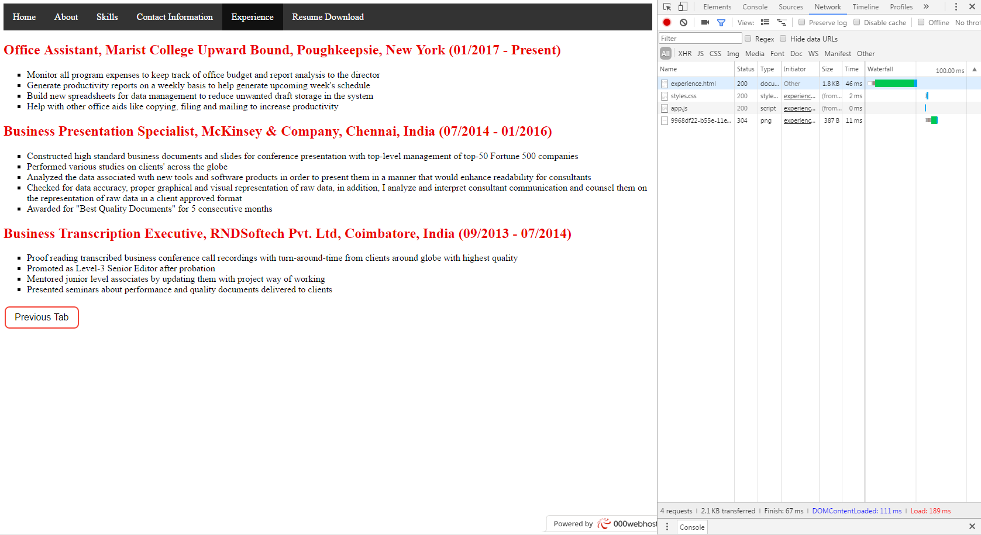

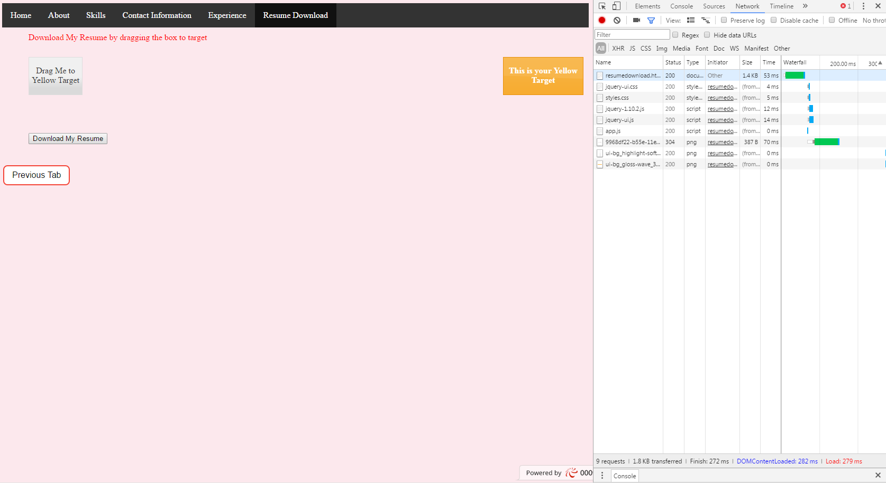

**Q4. How much of a performance increase were you able to gain by taking these simple actions?**

**Ans:**

There was a drastic improvement in the Google’s Page Speed Insights, which implies that these actions are kind of mandatory so that it improves the webpages loading time and performance. Initially, as you can see from screenshots, pages loaded more than 3s before minifying and compressing images. But after these steps, loading time decreased to less 300ms which is more than 1,000% improvement in saving time to load pages.